

Protect yourself from bushfire air pollution
With Sydney and its surrounds choking in a cloak of bushfire smoke, toxic air quality levels have reached new records.
Air pollution levels have soared up to 12 times higher than the ‘hazardous’ threshold and Sydneysiders have been advised to cut back on outdoor physical activity to avoid ingesting more pollutants.
Our pharmacy has definitely seen an increase in requests for face masks and those with breathing conditions like asthma, respiratory and cardiac conditions, pregnant women, young children and babies are most affected by the poor air quality.
How does bushfire smoke affect your body?
The main health culprit is the miniscule PR2.5 solid particles in bushfire smoke (i.e. particulate matter less than 2.5 micrometres in diameter).
Your body sees these particles as a foreign object, triggering a defensive inflammatory response like coughing, sore throat and itchy eyes. As they are so small, the particles can enter the bloodstream and reach the lungs and heart to cause myriad problems.
How to protect yourself and your family
On particularly smoky days, the best line of defence is to:
- Limit your exposure and stay inside and close all windows
- If possible, use a good quality air purifier with a HEPA filter to clean the indoor air
- Avoid outdoor physical exertion
- Ensure you have ample supply of medications for existing health conditions (like asthma puffers and heart and lung medications)
If you have any questions about minimising the effects of poor air quality, come and see us at O’Loughlin’s Medical Pharmacy or call us on (02) 9440 0030.

Facebook post
Hazardous air pollution from the devastating NSW bushfires is causing an alarming rise in health-related conditions. Check out our article to learn how to protect yourself and your family. https://bit.ly/2ObBYSs
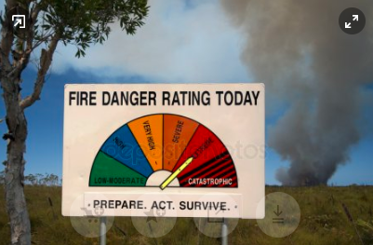

Instagram post
Hazardous air pollution from the devastating NSW bushfires is causing an alarming rise in health-related conditions. Read the link in our bio to learn how to protect yourself and your family. https://bit.ly/2ObBYSs
#healthicare #oloughlinsmedicalpharmacy #stivesshoppingvillage #stivesvillage #stiveschemist
#pricelinepharmacytheponds #thepondsshoppingcentre #thepondspharmacy #thepondschemist #theponds #hillsdistrict #hillsdistrictmums #sydneyhillsdistrict
#pharmacy #pharmacist #chemist #chemists #health #airpollution @asthma #breathing difficulties #bushfire

Image:
